ENZYMES
Topic for – Paper-PHYG, CC -1
(Biophysical principles, Enzymes and Chemistry of Bio-molecules)
Nadim Haider, Assistant Professor and HOD, Department of Physiology,
Netaji Nagar Day College, Kolkata-700092, West Bengal

Introduction:
The human body is composed of different types of cells, tissues and other complex organs. For efficient functioning, our body releases some chemicals to accelerate biological processes such as respiration, digestion, excretion and a few other metabolic activities to sustain a healthy life. Hence, enzymes are pivotal in all living entities which govern all the biological processes. Thus, “Enzymes can be defined as biological polymers that catalyze biochemical reactions.”
The initial stage of metabolic process depends upon the enzymes, which react with a molecule and is called the substrate. Enzymes convert the substrates into other distinct molecules, which are known as products.
The regulation of enzymes has been a key element in clinical diagnosis because of their role in maintaining life processes.

Chemical nature:
The macromolecular components of all enzymes consist of protein, except in the class of RNA catalysts called ribozymes. The word ribozyme is derived from the ribonucleic acid enzyme. Many ribozymes are molecules of ribonucleic acid, which catalyze reactions in one of their own bonds or among other RNAs. A large protein enzyme molecule is composed of one or more amino acid chains called polypeptide chains. The amino acid sequence determines the characteristic folding patterns of the protein’s structure, which is essential to enzyme specificity.

Enzyme Structure
Enzymes are a linear chain of amino acids, which give rise to a three-dimensional structure. The sequence of amino acids specifies the structure, which in turn identifies the catalytic activity of the enzyme. Upon heating, the enzyme’s structure denatures, resulting in a loss of enzyme activity, which typically is associated with temperature.
It should be noted that although a large number of enzymes consist solely of protein, many also contain a non-protein component, known as a cofactor, that is necessary for the enzyme’s catalytic activity. A cofactor may be another organic molecule, in which case it is called a coenzyme, or it may be an inorganic molecule, typically a metal ion such as iron, manganese, cobalt, copper or zinc. A coenzyme that binds tightly and permanently to the protein is generally referred to as the prosthetic group of the enzyme. When an enzyme requires a cofactor for its activity, the inactive protein component is generally referred to as an apoenzyme, and the apoenzyme plus the cofactor (i.e. the active enzyme) is called a holoenzyme (Figure 6.2). The need for minerals and vitamins in the human diet is partly attributable to their roles within metabolism as cofactors and coenzymes.
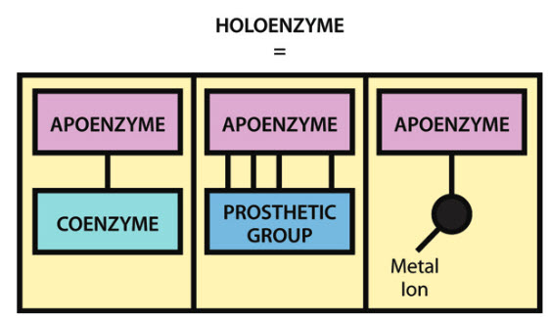

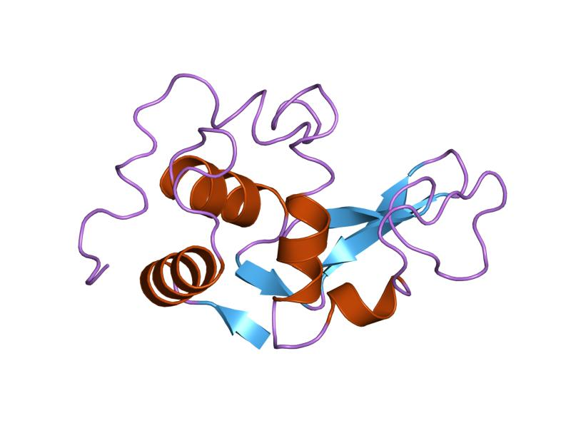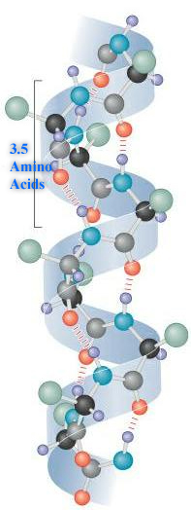

Enzymes Classification:
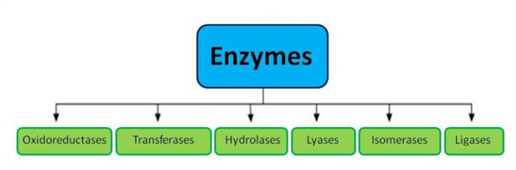
According to the International Union of Biochemists (I U B), enzymes are divided into six functional classes and are classified based on the type of reaction in which they are used to catalyze. The six kinds of enzymes are hydrolases, oxidoreductases, lyases, transferases, ligases and isomerases.

Listed below is the classification of enzymes discussed in detail:

Types | Biochemical Property
Oxidoreductases | The enzyme Oxidoreductase catalyzes the oxidation reaction where the electrons tend to travel from one form of a molecule to the other.
Transferases | The Transferases enzymes help in the transportation of the functional group among acceptors and donor molecules.
Hydrolases | Hydrolases are hydrolytic enzymes, which catalyze the hydrolysis reaction by adding water to cleave the bond and hydrolyze it.
Lyases | Adds water, carbon dioxide or ammonia across double bonds or eliminate these to create double bonds.
Isomerases | The Isomerases enzymes catalyze the structural shifts present in a molecule, thus causing the change in the shape of the molecule.
Ligases | The Ligases enzymes are known to charge the catalysis of a ligation process.

Mechanism of Enzyme action
Any two molecules have to collide for the reaction to occur along with the right orientation and a sufficient amount of energy. The energy between these molecules needs to overcome the barrier in the reaction. This energy is called activation energy.
Enzymes are said to possess an active site. The active site is a part of the molecule that has a definite shape and the functional group for the binding of reactant molecules. The molecule that binds to the enzyme is referred to as the substrate group. The substrate and the enzyme form an intermediate reaction with low activation energy without any catalysts.
Once substrate (S) binds to this active site, they form a complex (intermediate-ES) which then produces the product (P) and the enzyme (E). The substrate which gets attached to the enzyme has a specific structure and that can only fit in a particular enzyme. Hence, by providing a surface for the substrate, an enzyme slows down the activation energy of the reaction. The intermediate state where the substrate binds to the enzyme is called the transition state. By breaking and making the bonds, the substrate binds to the enzyme (remains unchanged), which converts into the product and later splits into product and enzyme. The free enzymes then bind to other substrates and the catalytic cycle continues until the reaction completes.

The enzyme action basically happens in two steps:
Step1: Combining of enzyme and the reactant/substrate.
E+S → [ES]
Step 2: Disintegration of the complex molecule to give the product.
[ES]→E+P
Thus, the whole catalyst action of enzymes is summarized as:
E + S → [ES] → [EP] → E + P
Active site:
Enzymatic catalysis depends upon the activity of amino acid side chains assembled in the active centre. Enzymes bind the substrate into a region of the active site in an intermediate conformation.
Often, the active site is a cleft or a pocket produced by the amino acids which take part in catalysis and substrate binding. Amino acids forming an enzyme’s active site is not contiguous to the other along the sequence of primary amino acid. The active site amino acids are assembled to the cluster in the right conformation by the 3-dimensional folding of the primary amino acid sequence. The most frequent active site amino acid residues out of the 20 amino acids forming the protein are polar amino acids, aspartate, cysteine, glutamate, histidine, Serine, and lysine. Typically, only 2-3 essential amino acid residues are involved directly in the bond causing the formation of the product. Glutamate, Aspartate, and Histidine are the amino acid residues which also serve as a proton acceptor or donor.
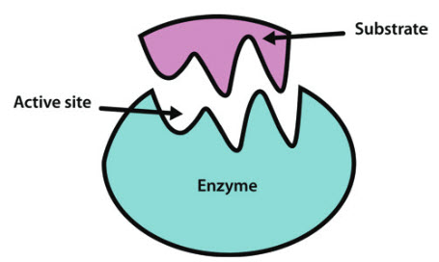
Different Models of enzyme action:
There are two models used to describe the way enzymes interact with substrates:
- The 'lock and key’ model
- The ‘induced fit’ model

The Lock and Key Model:

According to the lock and key model, the enzyme’s active site complements the substrate precisely
The substrate fits a particular active site like a key fits into a particular lock
This theory of enzyme-substrate interaction explains how enzymes exhibit specificity for a particular substrate
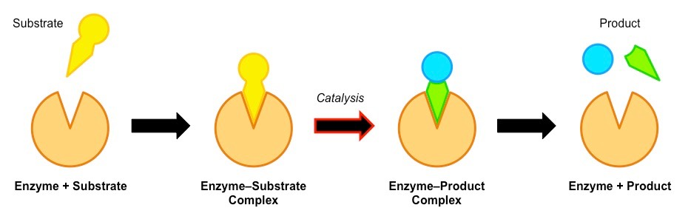

The Induced Fit Model:

According to the induced fit model, the enzyme’s active site is not a completely rigid fit for the substrate
Instead, the active site will undergo a conformational change when exposed to a substrate to improve binding
This theory of enzyme-substrate interactions has two advantages compared to the lock and key model:
- It explains how enzymes may exhibit broad specificity (e.g. lipase can bind to a variety of lipids)
- It explains how catalysis may occur (the conformational change stresses bonds in the substrate, increasing reactivity)

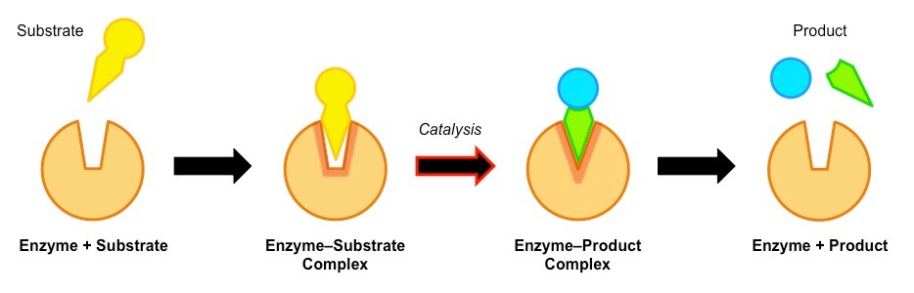

Factors affecting enzyme action:
The conditions of the reaction have a great impact on the activity of the enzymes. Enzymes are particular about the optimum conditions provided for the reactions such as temperature, pH, alteration in substrate concentration, etc.

Temperature and pH
Enzymes require an optimum temperature and pH for their action. The temperature or pH at which a compound shows its maximum activity is called optimum temperature or optimum pH, respectively. As mentioned earlier, enzymes are protein compounds. A temperature or pH more than optimum may alter the molecular structure of the enzymes. Generally, an optimum pH for enzymes is considered to be ranging between 5 and 7.
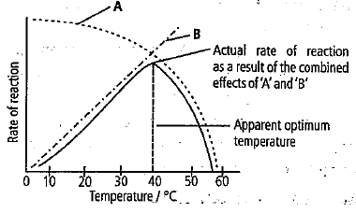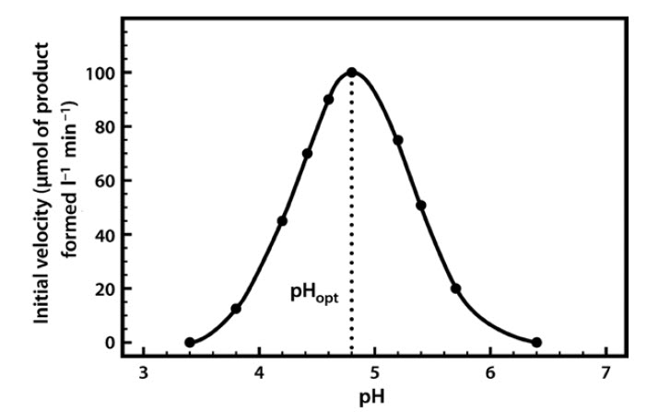

- Optimum T°
- The greatest number of molecular collisions
- human enzymes = 35°- 40°C
- body temp = 37°C
- Heat: increase beyond optimum T°
- The increased energy level of molecule disrupts bonds in enzyme & between enzyme & substrate H, ionic = weak bonds
- Denaturation = lose 3D shape (3° structure)
- Cold: decrease T°
- Molecules move slower decrease collisions between enzyme & substrate

Concentration and Type of Substrate
Enzymes have a saturation point, i.e., once all the enzymes added are occupied by the substrate molecules, its activity will be ceased. When the reaction begins, the velocity of enzyme action keeps on increasing on further addition of substrate. However, at a saturation point where substrate molecules are more in number than the free enzyme, the velocity remains the same.
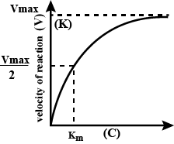
The type of substrate is another factor that affects the enzyme action. The chemicals that bind to the active site of the enzyme can inhibit the activity of the enzyme and such substrate is called an inhibitor. Competitive inhibitors are chemicals that compete with the specific substrate of the enzyme for the active site. They structurally resemble the specific substrate of the enzyme and bind to the enzyme and inhibit the enzymatic activity. This concept is used for treating bacterial infectious diseases.

Salt concentration
Changes in salinity: Adds or removes cations (+) & anions (–)
- Disrupts bonds, disrupts the 3D shape
- Disrupts attractions between charged amino acids
- Affect 2° & 3° structure
- Denatures protein
- Enzymes intolerant of extreme salinity
- The Dead Sea is called dead for a reason

Functions of Enzymes
The enzymes perform a number of functions in our bodies. These include:
- Enzymes help in signal transduction. The most common enzyme used in the process includes protein kinase that catalyzes the phosphorylation of proteins.
- They break down large molecules into smaller substances that can be easily absorbed by the body.
- They help in generating energy in the body. ATP synthase is the enzyme involved in the synthesis of energy.
- Enzymes are responsible for the movement of ions across the plasma membrane.
- Enzymes perform a number of biochemical reactions, including oxidation, reduction, hydrolysis, etc. to eliminate the non-nutritive substances from the body.
- They function to reorganize the internal structure of the cell to regulate cellular activities.

